**Leader Overview**

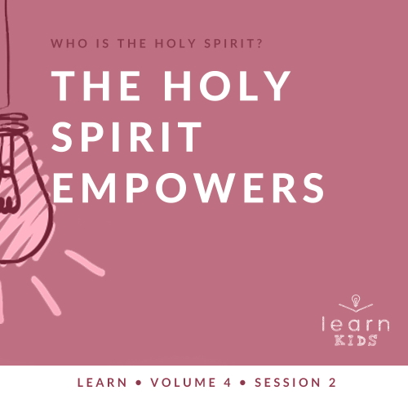

**Volume Overview**

**Who is the Holy Spirit?**

*In His most famous sermon (*[*Matthew 5–7*](https://ref.ly/logosref/Bible.Mt5-7)*), Jesus taught us to love our enemies, give to the needy, and put God’s kingdom first in our life. These high expectations don’t take us long to recognize a problem. We simply can’t do this on our own. So, why did Jesus command us to live a life He knows full well we cannot live on our own? The key is that Jesus never asked us to live the Christian life on our own. In fact, Jesus explained there is a gift that is indispensable for every Christian: the Holy Spirit. Jesus as God in the flesh is a wonderful gift, and God living inside us is amazing too! God living within us can empower us, help us grow, and equip us in a unique way that God among us could not*.

**Session Overview**

**The Holy Spirit Empowers**

*Peter had been skeptical of telling Gentiles about Jesus, but God used Peter when the first Gentiles were baptized in the Holy Spirit. Cornelius was a devout man of faith in God, and God filled him with the gift of the power of the Holy Spirit after he believed in Jesus. This story proves that the power that comes from the baptism in the Holy Spirit is a gift that is available for all believers*.

**Bible Lesson**

Cornelius Is Baptized in the Holy Spirit

[Acts 10:1–8](https://ref.ly/logosref/Bible.Ac10.1-8), [19–23](https://ref.ly/logosref/Bible.Ac10.19-23), [44–48](https://ref.ly/logosref/Bible.Ac10.44-48)

**Faith Fact**

The Holy Spirit fills me with power.

**Faith Verse**

[Galatians 5:22–23](https://ref.ly/logosref/Bible.Ga5.22-23) (NLT)

The Holy Spirit produces this kind of fruit in our lives: love, joy, peace, patience, kindness, goodness, faithfulness, gentleness, and self-control.

**Preparing for the Session**

**Leader Preparation Time: 20–25 Minutes**

|  |
| --- |
| ***You Will Need***  ***Large Group***   * *Bible* * *Worship songs (Song suggestions: “Holy Spirit” by Kari Jobe; “Set a Fire” by Jesus Culture; “Come Holy Spirit” by Vertical Worship; “Zeal” by The Belonging Co)* * *For groups not using a phone or tablet only, add:*   *• Projector or TV*  *• Laptop*  *•* ***Faith Fact Slide***  *•* ***Faith Verse Video*** *or* ***Slide***  *•* ***Bible Lesson Video***  ***• Teaching Point Slides 1–3***  *• Wrapped present with a tag*  *• Piece of candy or a small prize*  ***Small Group***   * *Large bean bag* * *Floor-safe tape* * *Bibles for kids in your group to share* * *Stopwatch or timer on leader’s phone* * ***Small Group Activity Page****, one per kid* * *Pencils, one per kid* * *Crayons*   *To access session content and videos from a computer, visit:* [*BibleEngagementProject.com/downloads*](https://bibleengagementproject.com/downloads) |
| ***Getting Ready***  ***Large Group***   * *Download videos and slides if needed.* * *Select worship song(s) and have them ready to play.* * *Read the Bible Lesson Scripture to prepare for teaching time.* * *Place a tag on the wrapped present and write on it: Do not open unless you have met Jesus.*   ***Small Group***   * *Put a line of floor-safe tape on the floor for the starting line.* * *Print copies of the* ***Small Group Activity Page****, one per kid.*   ***First time leading* Learn *for Kids? Check out the*** [***Facilitator Guide***](https://0b769b0ed3569ef9d18b-f88d8272f61086866d50d048b43ef630.ssl.cf2.rackcdn.com/sites/biblengagementproject/Listen_Facilitator_Guide.pdf)***.*** |

**Large Group**

**30 Minutes**

*See what’s needed at the beginning of the session.*

**Introduction**

Hey, kids! I hope everyone is having a great week. I’m so glad you’re here to learn more about the Holy Spirit. Oops! I just gave you a hint. Does anyone remember the big question we’re answering? *(Allow responses.)* Our question is: Who is the Holy Spirit?

Yell it out if you know the answer. Last time we learned that the Holy Spirit is _______. *(Group response)* You’re right. The Holy Spirit is God. He’s one of three Persons who our God has shown himself to us through. There’s the Father, Jesus, and the Holy Spirit.

**Faith Fact**

Our time together today is going to be powerful because we’ll talk about how the Holy Spirit empowers us. Our Faith Fact today is: **The Holy Spirit fills me with power**.

• *Show the* ***Faith Fact Slide***.

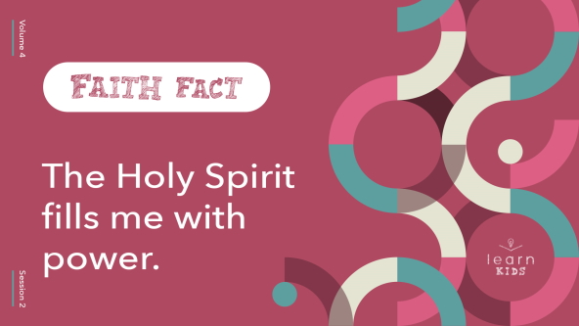

Can you say that with me one more time? **The Holy Spirit fills me with power**. Show me your arm muscles and say it with your strongest voice. **The Holy Spirit fills me with power**. Great job!

Who likes to be the one in charge? Who likes to call all the shots and tell everyone what to do? Raise your hand if you enjoy that. *(Group response)* Even more important than us leading on our own is when the power comes from the Holy Spirit. Let’s find out more.

**Game**

**Gaining Power**

Today, we’ll play a game about increasing in power. Let’s see how strong our power can get. The person who starts will make a sound and do an action, but it has to be quiet and small. For example, you might put your finger to your lips and say, “Shhh!” quietly, or you might put your arms around yourself like you’re cold and shiver quietly. Then, the person right beside you will make that sound a little louder and do that action a little bigger. It’s almost like we turned the volume up just a little each time. Let’s see if we can get a little louder and bigger until we get back to the first person to show us their action big and strong. Here we go.

• *Depending on the size of your group, you may choose to form multiple circles*.

• *Continue around the circle with each player adding more energy. When everyone has had a turn, the starting player must do the action/sound combo once more at the highest intensity yet to finish off the round*.

• *Choose another player to start a new round with a new sound and action*.

I liked how you added power to those noises and actions. That reminds me of today’s Faith Fact. The Holy Spirit gives us extra power to do amazing things for God. Say the Faith Fact with me. **The Holy Spirit fills me with power**.

**Worship**

Let’s worship God and praise Him for His powerful Holy Spirit at work in our life. We can do that by singing to Him.

• *Lead the kids in singing one or two praise songs. See suggestions at the beginning of the session*.

**Bible Lesson**

I hope you enjoyed our time of singing and worship as much as I did. The Holy Spirit hears and sees everything we do, including our worship. Who can remember why? *(Allow responses.)* Last time, we learned that the Holy Spirit is God. He lives in you and me. We’re about to learn something new about who the Holy Spirit is and what He does. As we start, let’s pray.

**Prayer**

|  |
| --- |
| *Dear God, thank You for Your powerful Holy Spirit. Help us to learn and receive something new from You today. Amen.* |

**Video Intro**

Before we look at the Bible story, let’s watch this video.

• *Play* ***Bible Lesson Video***.

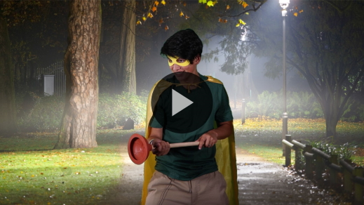

**Bible Story**

**Cornelius Is Baptized in the Holy Spirit**

That was a great intro to our Bible story. When Jesus went back to heaven, He promised the gift of the Holy Spirit. A few weeks later, His disciples were baptized in the Holy Spirit. More people experienced the baptism in the Holy Spirit, but they were all Jews like Jesus and His disciples. In today’s Bible story, the Holy Spirit changed that. He makes something totally unexpected and shocking happen. If you want to follow along, open your Bible to [Acts 10](https://ref.ly/logosref/Bible.Ac10).

• *Read the Bible story in* [*Acts 10:1–8*](https://ref.ly/logosref/Bible.Ac10.1-8)*,* [*19–23*](https://ref.ly/logosref/Bible.Ac10.19-23)*,* [*44–48*](https://ref.ly/logosref/Bible.Ac10.44-48) *aloud to the group*.

• *In order to keep Large Group time moving along, we don’t recommend having the kids read*.

• *Optional: Remind the kids to mark this place with their Bible Bookmark, so they can read it on their own at home*.

**Teaching Time**

|  |
| --- |
| ***You Will Need***   * *Wrapped present with a tag* * *Piece of candy or a small prize*   ***Getting Ready***   * *Place a tag on the wrapped present and write on it: Do not open unless you have met Jesus.* |

This story may not be surprising to all of us because we’ve heard that salvation and the power of the Holy Spirit are available to everyone. In the early New Testament times, this was a new and unusual teaching. Some people rejected it.

**1. The power of the Holy Spirit is a gift for all believers**.

• *Show the* ***Teaching Point 1 Slide***.

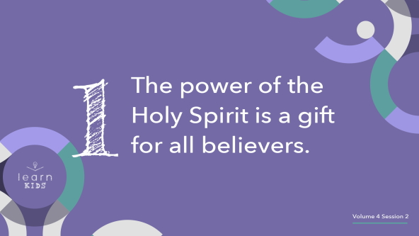

Even today there are some people who believe in God, but they don’t think the gift of the Holy Spirit that Jesus promised is for us today. Oh! This present has a tag on it. Let’s see what it says.

• *Read the tag aloud to the kids. “Do not open unless you have met Jesus.”*

Hey! Does that sound right to you? The Bible story we just read about Cornelius and his family teaches us that the gift of the Holy Spirit is for everyone who believes in Jesus. In New Testament times, Jesus’ disciples weren’t sure if Cornelius and his family could receive the power of the Holy Spirit because they were Gentiles. Does anyone know what *Gentile* means? *(Allow responses.)*

Some people in Bible times called everyone who wasn’t Jewish a Gentile. God had a special relationship with the Jewish people. When Jesus was on earth, some Jews believed that they were the only people God truly cared about. That wasn’t true. When Jesus died on the Cross, He died for everyone.

Then, Jesus called His disciples together right before He went back to heaven. He told them to go out and tell everyone about His gift of salvation. The story of Cornelius and his family receiving the gift of the Holy Spirit helps us know that the Holy Spirit is for all believers, including us.

**2. The Holy Spirit is ready to connect with everyone who seeks God**.

• *Show the* ***Teaching Point 2 Slide***.

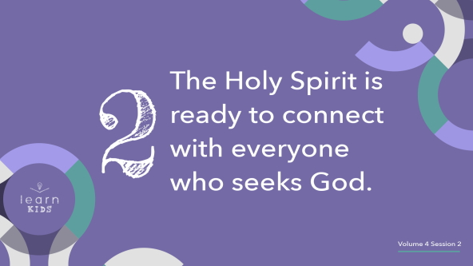

The Bible makes it clear that Cornelius was a devout, God-fearing man. What do you think that means? *(Allow responses.)* I think it means he was a faithful follower of God who spent a lot of time in prayer with Him. God responded to Cornelius’s faith by sending Peter to tell him about Jesus and then by filling him with the power of the Holy Spirit.

God wants to connect with us through His Holy Spirit, but He won’t force His way into our life. [Acts 10](https://ref.ly/logosref/Bible.Ac10) doesn’t say that an angel randomly appeared to Cornelius in a vision and then he believed and spent time with God. First, Cornelius was faithful in praying to God regularly.

• *Get down on your knees to demonstrate praying*.

He gave generously to others.

• *Get up and hand a kid a piece of candy or a prize*.

Then, after hearing and accepting the truth about Jesus, he was baptized in the Holy Spirit. Like Cornelius, we should make time to pray regularly and seek God like Cornelius did.

**3. The power of the Holy Spirit equips us for service**.

• *Show the* ***Teaching Point 3 Slide***.

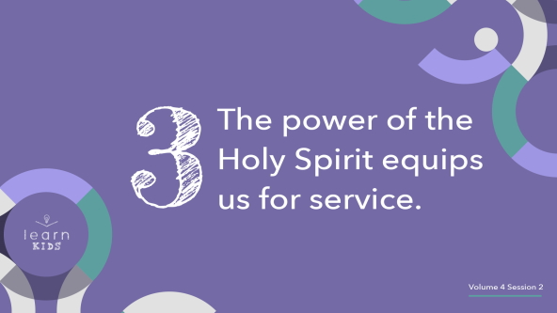

Do you believe in God? *(Group response)* Would other people know that you are His follower? *(Group response)* That’s one way the power of the Holy Spirit helps us. The Holy Spirit enables us to do the things that God wants us to do.

Peter is a great example of the power of the Holy Spirit at work. Peter was known for his boldness even before he was baptized in the Holy Spirit, but sometimes his boldness to speak up or jump into action got him in trouble. But, when the Holy Spirit’s power was added to Peter’s boldness, thousands of people believed in Jesus, were saved, and became followers of Jesus.

• *Give the present with the tag removed to a kid*.

• *Have the kids pass the gift to the person next to them until the gift has made its way to every kid in the room*.

Just as you’re passing this gift around, the Holy Spirit can give us boldness to tell others about the good news of Jesus. That’s what our Faith Fact is about. Say it with me. **The Holy Spirit fills me with power**. He wants to give us power to tell others about Jesus and then they can receive the gift of the Holy Spirit, too.

**Prayer and Response**

*Consider playing a worship song softly in the background while kids pray*.

Jesus promised the gift of the Holy Spirit. Our Bible story about Cornelius shows us that everyone can receive that gift. Raise your hand if you would like more of the Holy Spirit in your life. *(Group response)* Let’s take a look at what happened with Cornelius and the other Gentiles who were there that day. We already know that they were followers of God. Then after they heard and accepted what Peter said about Jesus, they were baptized in the Holy Spirit.

• *Be sensitive to the Holy Spirit’s leading and share more about salvation here if needed*.

[Acts 10:45–46](https://ref.ly/logosref/Bible.Ac10.45-46) says, “The Jewish believers who came with Peter were amazed that the gift of the Holy Spirit had been poured out on the Gentiles, too. For they heard them speaking in other tongues and praising God.” That’s how we know they were filled with the Holy Spirit. They spoke in a language they didn’t know. If you would like to receive the power of the Holy Spirit and His baptism today, raise your hand.

• *Allow kids to respond by raising their hand*.

Let’s begin praying and praising God, and ask Him to give us this gift. You may or may not receive the Holy Spirit the first time you pray. It’s important to begin to seek God. That’s what Cornelius was doing before Peter came to tell him about Jesus and the Holy Spirit.

• *Allow time for the kids to pray and ask for the baptism in the Holy Spirit. You may want to use your leaders to pray with the kids and help them understand what they are praying for*.

Remember, we need to spend time connecting with God regularly. If you don’t receive the baptism in the Holy Spirit today, you might receive it when you are at home like Cornelius did. The important thing is to spend time with God every day and be open to receiving this gift. Let’s thank the Holy Spirit for being with us.

**Prayer**

• *Optional: Have the kids repeat phrases of the prayer after you*.

|  |
| --- |
| Father God, we want more of Your Holy Spirit in our life. Come and fill us with Your power so we can do the work You put us on this earth to do. Amen. |

**Faith Verse**

Our Faith Verse tells us how the Holy Spirit will help us grow. Let’s watch the video for our Faith Verse and do the actions. This fruit our Faith Verse talks about can be so powerful when the Holy Spirit grows it in our life.

• *Play* ***Faith Verse Video***.

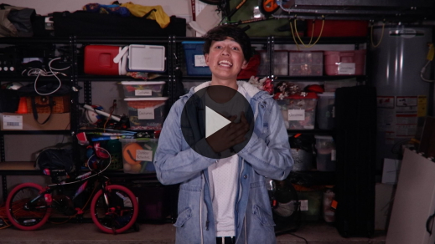

[Galatians 5:22–23](https://ref.ly/logosref/Bible.Ga5.22-23) (NLT)

The Holy Spirit produces this kind of fruit in our lives: love, joy, peace, patience, kindness, goodness, faithfulness, gentleness, and self-control.

**Faith Fact**

Before we go to our small groups, let’s review our Faith Fact again: **The Holy Spirit fills me with power**. I want the Holy Spirit to fill me with His power. How about you? *(Group response)*

• *Show the* ***Faith Fact Slide***.



Thanks for learning more about the Holy Spirit with me. We’ll learn more in our small groups.

• *Dismiss kids to Small Group time or to go home if your group time ends here*.

**Small Group**

**30 Minutes**

*This section can be done in conjunction with the large group or on its own if you do small groups with your kids. During Small Group time, the goal is to connect the kids with the Word of God and to each other. All activities are led by the small group leader.*

**Group Connection**

**Power Races**

|  |
| --- |
| ***You Will Need***   * *Large bean bag* * *Floor-safe tape*   ***Getting Ready***   * *Put a line of floor-safe tape on the floor for the starting line.* |

The Holy Spirit is far more powerful than any of us. Do you believe that? *(Group response)* It’s so amazing that we have access to His power just like our Faith Fact says. Say it with me. **The Holy Spirit fills me with power**.

Speaking of power, do you believe I’m more powerful and stronger than all of you? *(Group response)* Let’s see who is the most powerful in this group. I’m going to throw this bean bag as far as possible. Here’s the catch. We have to toss it underhand. After I throw it, we’ll put a small piece of tape on the floor where the bean bag lands. Then, it’s your turn. Whoever throws it the farthest will get to lead our next game.

• *Allow each kid to throw the bean bag. If the leader’s bag went the farthest, they’ll lead the game. If a kid throws it farther, allow them to lead the game*.

Okay, I believe we have our “powerful” leader for the game. Here’s how we’ll play. For each round, the leader will throw the bean bag as far as possible and two of you will race to see who can grab the bean bag first and bring it back to the leader. Let’s begin the power races.

• *Pair kids up who are about the same size to race against each other. Have them stand at the starting line*.

• *For each round, have the leader throw the bean bag as far across the room as they can. Keep playing until all the pairs have had a chance to race*.

• *Optional: Do a winner round and allow all the winners to race against each other to declare an ultimate winner*.

It’s easy to think that being the leader is the best thing to be. When it comes to the Holy Spirit, He should be the Leader, and we’re like the runners. He will show us where to go and what to do when He empowers us.

Cornelius followed God’s leading in today’s Bible story. Then, the Holy Spirit told Peter to go to Cornelius. The Holy Spirit empowered Peter to share about Jesus with Cornelius and everyone who was with him. That’s what our Faith Fact looks like in action. Let’s say it together. **The Holy Spirit fills me with power**.

**Learn about It**

|  |
| --- |
| ***You Will Need***   * *Bibles for kids in your group to share*   *No prep needed for this activity.* |

**Scripture Search:** [**Acts 1:1–5**](https://ref.ly/logosref/Bible.Ac1.1-5)**,** [**6–9**](https://ref.ly/logosref/Bible.Ac1.6-9)**,** [**2:16–18**](https://ref.ly/logosref/Bible.Ac2.16-18)**,** [**38–39**](https://ref.ly/logosref/Bible.Ac2.38-39)

Let’s dig deeper into God’s Word and see what else He has to say about the Holy Spirit. As we find and read each of these verses, let’s consider: What does this Scripture mean for our life today?

• *Give each kid a Bible and search for one or more of the Scriptures as a group together (as time allows). When everyone has found the Scripture, have one of the kids read it. Then, answer the questions about it*.

• *Pair kids who need additional help with older kids or start simple and look up the session’s Bible story Scripture:* [*Acts 10:1–8*](https://ref.ly/logosref/Bible.Ac10.1-8)*,* [*19–23*](https://ref.ly/logosref/Bible.Ac10.19-23)*,* [*44–48*](https://ref.ly/logosref/Bible.Ac10.44-48)*. Kids will get better finding Scriptures the more they practice*.

• *Optional: Make this a competition to see who can find the Scripture first*.

**Bible Reading Tip**

We should expect the Holy Spirit to speak to us through God’s Word. Sometimes when you’re reading your Bible, a verse, sentence, or even phrase might stick out to you. Take time to highlight or underline the words when something sticks out to you. Then, the next time you’re reading that passage in the Bible you’ll be reminded of what the Holy Spirit spoke to you before.

**Challenge**

Memorizing God’s Word is important, too. I challenge you to say the Faith Verse [Galatians 5:22–23](https://ref.ly/logosref/Bible.Ga5.22-23) every day. If you don’t know it yet, put your ***Activity Page*** somewhere you can see it often. Then, every time you walk by read or say the Faith Verse out loud.

**Faith Fact**

All of our Bible reading is a reminder to me of our Faith Fact. Say it with me:

**The Holy Spirit fills me with power**.

**Group Discussion**

*Feel free to use all or just a few questions as a jumping-off place for good discussion. Questions marked with * are designed for more conversation. Adjust the questions based on the age or maturity of your group. Typically, older kids will be able to dive a little deeper than younger ones*.

**Questions**

• *If small group activities are not immediately following large group time, you may want to read the Bible story passage before this discussion*.

How does the Bible describe Cornelius?

How did God get a message to Cornelius?

How did Peter find out he needed to go visit Cornelius and his family?

What special thing happened when Peter visited Cornelius?

* Do you believe the Holy Spirit can empower you? Why or why not?

* Why do you need the power of the Holy Spirit in your life?

Why do you think the baptism in the Holy Spirit is important for us?

How can people be open to receiving the gift of the Holy Spirit in their life?

* How can we connect with the Holy Spirit every day and seek God regularly like Cornelius did?

**Prayer Requests**

*Finish group discussion by sharing prayer requests and praise reports. Keep track of your small group’s prayer requests and review them each time you meet*.

**Prayer**

*Have kids pray for each other’s prayer requests*.

**Faith Verse Review**

|  |
| --- |
| ***You Will Need***   * *Stopwatch or timer on leader’s phone*   *No prep needed for this activity.* |

Our Faith Verse is [Galatians 5:22–23](https://ref.ly/logosref/Bible.Ga5.22-23). It talks about the powerful fruit the Holy Spirit grows in our life. Let’s watch the Faith Verse video and do the actions together.

• *Show* ***Faith Verse Video***.



[Galatians 5:22–23](https://ref.ly/logosref/Bible.Ga5.22-23) (NLT)

The Holy Spirit produces this kind of fruit in our lives: love, joy, peace, patience, kindness, goodness, faithfulness, gentleness, and self-control.

**Faith Verse Fun**

**Power Up Verse**

We’re going to play a game to help us remember our Faith Verse. It’s called Power Up Verse. We’ll go around the circle and each person will say one word of the Faith Verse. When you say your word, “power up.” You’ll jump up as fast as possible and say your word. I think we should see how fast we can “power up” the verse, so let’s time ourselves each time.

• *Play several times, timing the kids each time. Try to beat your previous time each time you say the verse*.

Our Faith Verse teaches us part of what the Holy Spirit wants to do in our life. He is always growing this fruit in our life if we let Him.

**Activity Page**

**Share Jesus’ Love**

|  |
| --- |
| ***You Will Need***   * ***Small Group Activity Page****, one per kid* * *Pencils, one per kid* * *Crayons*   ***Getting Ready***   * *Print copies of the* ***Small Group Activity Page****, one per kid.* |

In our Bible story today, the Holy Spirit told Peter to go to Cornelius. The Holy Spirit wants us to tell others about Jesus, too. Think about who in your life needs to know more about Jesus. Draw them on your ***Activity Page*** and then color them. When you get ready to share with them, remember our Faith Fact. Say it with me. **The Holy Spirit fills me with power**.

• *Give each kid a copy of the* ***Small Group Activity Page****, a pencil, and crayons to complete the page*.

**Dismissal**

One of the best things we learned today is that we don’t have to go through life on our own strength. We can allow the power of the Holy Spirit to fill us. He can empower us to do everything God has called us to do.

**Prayer**

|  |
| --- |
| *Dear God, thank You for allowing us to receive the power of the Holy Spirit. Help us to learn to rely on Your power instead of our own strength. Amen.* |

**Faith Fact Recap**

• *Show the* ***Faith Fact Slide***.



One thing I want you to remember from today is our Faith Fact. Let’s say it together: **The Holy Spirit fills me with power**. I’m glad you came today. I can’t wait to see you next time.

• *Send home the* ***Small Group Activity Page***.

• *Remind parents that there are* ***Family Devotions*** *available on the app to do with their kid*.

• *Tell everyone the date and time for the next session*.